MECHANICAL DESIGN ASSIGNMENT
Task 1: 3D Model Creation (Stepped Shaft)

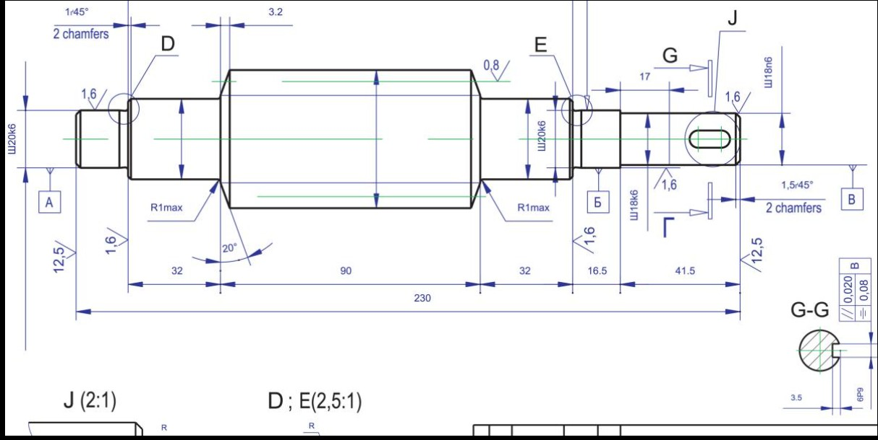

Figure 1.0: Technical dimensioning and geometric specifications for the Stepped Shaft.

Design Report: Stepped Shaft Assembly

OBJECTIVE
The primary objective of this project was to engineer a high-precision mechanical shaft utilizing industry- standard CAD protocols. The design focuses on structural integrity, functional clearance, and adherence to specific dimensional constraints required for industrial rotational assemblies.

TECHNICAL DESCRIPTION
The component is a multi-stepped shaft designed with varying diameters to accommodate bearings, gears, or pulleys. Key design features include precision-machined chamfers for ease of assembly and fillets to minimize stress concentrations at diameter transitions. The total axial length is verified at 230 mm, ensuring compatibility with standard housing units.

MATERIAL SPECIFICATION
Primary Material: Mild Steel (Low Carbon Steel)
Selection Rationale: Mild steel was selected due to its optimal balance of high tensile strength and ductility. It provides the necessary durability for mechanical loading while remaining cost-effective for mass manufacturing. Its excellent machinability ensures that the precise tolerances defined in the CAD model can be achieved during the fabrication process.

CONCLUSION
The finalized CAD design of the stepped shaft successfully meets all mechanical requirements for rotational power transmission. The integration of proper tolerances and material properties ensures that the component is ready for simulated stress analysis and subsequent physical production.

